PERSONAL DATA

| **Name:** | Dmytro Viitenko |
| --- | --- |
| **Date of Birth:** | 07/10/1998 |
| **Location:** | Ukraine, Kyiv |
| **Mobile:** | +380 (97) 384-63-41 |
| **E-mail:** | dima.viitenko.work@gmail.com |
| **LinkedIn:** | [**www.linkedin.com/in/dimasoul**](http://www.linkedin.com/in/dimasoul) |
| **GitHub:** | [**https://github.com/DarkSoul-SP**](https://github.com/DarkSoul-SP) |

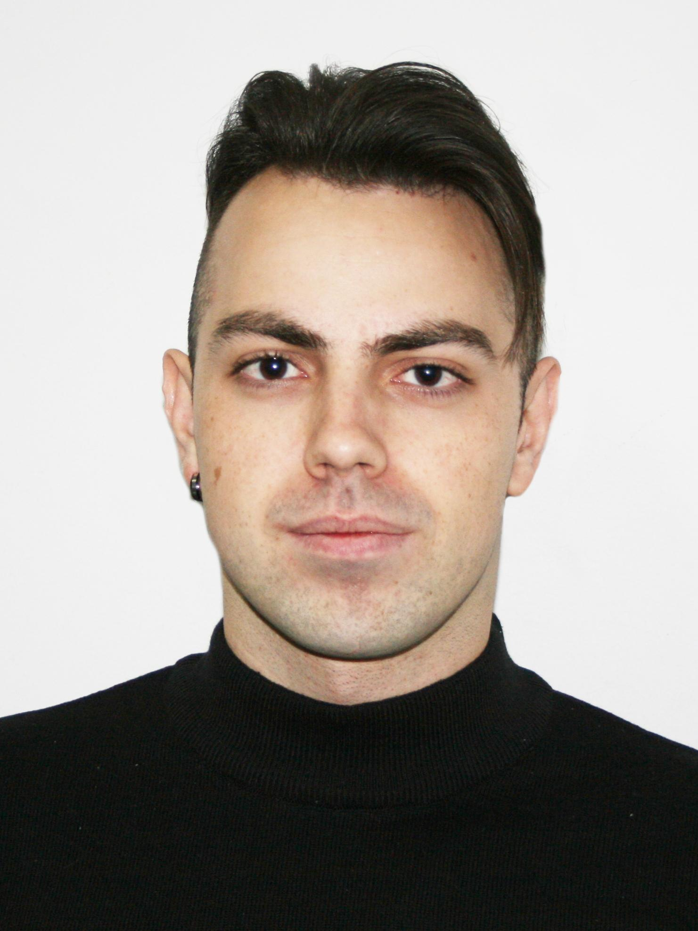

OBJECTIVE

| **Desired Position:** | Java software engineer |
| --- | --- |

SUMMARY OF QUALIFICATION

| **I have been working as a software engineer (with Java language) since the second part of 2018.** |
| --- |

TECHNICAL SKILLS

* **Java core and APIs**
* **Spring (main: Core, Boot, MVC, WebFlux, Data JPA/JDBC, Security)**
* **JPA (Hibernate, EclipseLink), ORM (Jooq)**
* **SQL (Oracle, Postgres), NoSQL(MongoDB)**
* **Rest, Graphql (with DGS framework and Apollo Federation)**
* **Keycloak**
* **Kafka, Kafka-streams**
* **JUnit, AssertJ, Hamcrest, Mockito, Cucumber, Wiremock**
* **Maven, Gradle**
* **Git (Github, Gitlab)**
* **Docker (with docker-compose), Kubernetes, Helm**
* **AWS (as a developer, not as cloud architect)**

RELEVANT EXPERIENCE

* **I have been working since the second part of 2018.**
* **Started as a freelancer (Oct 2018 - Mar 2019) – created APIs and implemented business logic on the backend side, worked with third-party APIs for students’ diplomas and laboratory works.**
* **After that worked at ProFix (banking field - Jul 2019 - Nov 2020 · 1 yr 5 mos):**
* **as a Junior java software engineer – fixed bugs and fails in logic. Also worked with SQL queries and reports (analytics);**

**as a Java software engineer:**

**- created new features for clients (new business logic on the backend side)**

**- new API endpoints;**

**- native and Spring Data queries to DB (Oracle, Postgres plain selects, aggregations);**

**- created DB updates - DDL;**

**- created updates for the report list;**

**- implemented integrations with third-party systems (via REST and SOAP);**

**- worked as a mentor for new teammates.**

**Main achievements: improved skills in the REST approach (created many new API points for various business purposes), worked with complex SQL queries in reports + code refactoring that led to performance improvement + first steps as a mentor for new teammates.**

* **Inmost (healthcare project - Dec 2020 - Mar 2021 · 4 mos) as a middle Java software engineer has participated in:**

**- features development, worked with Spring Data queries;**

**- improved performance for backend modules (profiling and refactoring for code-base);**

**- created API endpoints (Rest);**

**- managed and extended integration with CI app - Jenkins for microservices.**

**Main achievements: code refactoring with performance improvement, code review approach improvement in the team, and help with CI pipeline optimization.**

* **Digitally Inspired Ltd (retailing project - May 2021 - May 2023 · 2 yrs 1 mo) as a strong middle Java software engineer worked on the microservices platform (more than 100 different ms) that working on AWS under EKS-service:**

**- worked both alone and in communication with technical architects, teamlead, and engineers from my and third-party teams (integrations, devOps, frontend, mobile);**

**- took part in decisions call about new features, topology, solutions and other technical moments on the platform and team levels;**

**- took part in new ms design and creation (full lifecycle from technical design, solving problems or disputed points and implementation to helm chart creation with CI/CD deployment on k8s and documentation);**

**- researched and fixed problems on production env (only that related to deployed ms, not infrastructure);**

**Main achievements: mastering GraphQL and Kubernetes, contribution to the project framework (new features to libs for work with keycloak and kafka). I have worked on POCs (proof of concept for new features, technologies, and approaches which other teams will integrate) - researching and MVP implementation for them:   
 - Google Drive opportunities researching, and integration into our ms;  
 - created the first ms with DGS framework instead of default graphql-java libs.**

LANGUAGE

* **English – upper intermediate (have experience with international teams)**. **Ukrainian, Russian – native.**

EDUCATION

**Have a Master's Degree in Computer Science. 2016 – 2022 / NTUU “Igor Sikorsky Kyiv Polytechnic Institute”/ *Faculty* of heat *power engineering* / Computer sciences.**